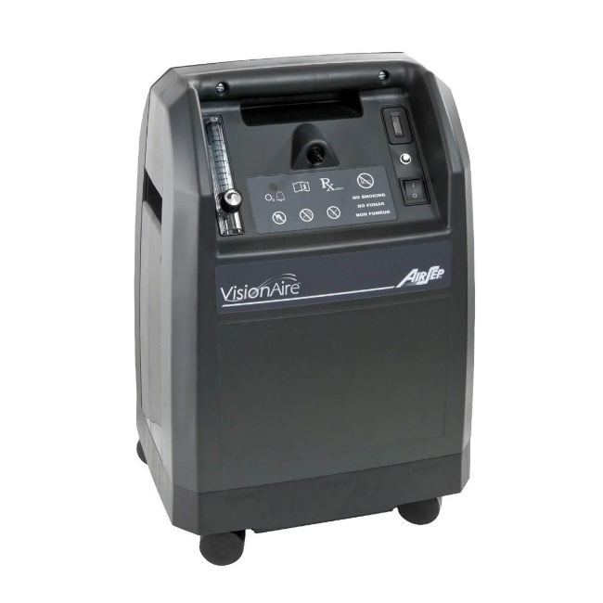
  - Visionaire 5 Oxygen Concentrator

A : Oxygen Outlet Port
B: Power Button (Switch On/Off)
C: Indicators
D: Flow Metre and Flowrate Control

How to operate the Oxygen Concentrator:
Switch On the Power Button (B)
Adjust the Flowrate (D) according to doctor’s advise
Connect breathing accessories to the Oxygen Outlet Port (A)
Let the Oxygen Concentrator run for at least 30 mins. Ensure there are no alarms, orange or red indicators lights (C)
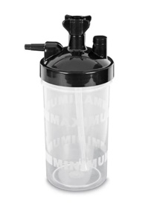
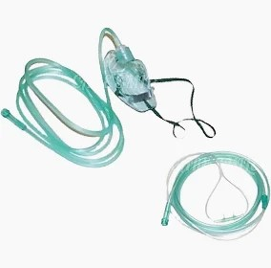

Breathing Accessories:

  Do’s |   Don’ts
- Keep the device in a well-ventilated room  - Keep a 30 cm gap between a hindrance and the device filter door  - Keep the device in an upright position always, even when transporting  - Change Humidifier water daily  - Water should be purified water  - Suitable for drinking water – Boiled/ Distilled/Sterile/RO  - If boiled water, ensure water is cooled to lukewarm.  - Follow Maintainance & Hygiene Guide | - Don’t block the airflow of the device. Avoid placing devices against the walls/furniture/ curtains.  - Do not share an extension cord with the device and any other appliances.  - Do not allow kids/pets near the device.  - Don’t keep the device inside a closed compartment  - Do not use oil or grease on the device

FIRE SAFETY

- DO NOT Smoke near the device
- DO NOT place the device near an open flame/source of heat area

  - Daily
Water MUST be changed daily
• Clean the Canister: Rinse with running water, using a sponge and soap to ensure its thoroughly cleaned.
• Fill the Canister: Use one of the following types of water: drinking water, distilled water, sterile water, or reverse osmosis water.
AVOID: Mineral or Saline Water
Replace Cannister every 2 Months

Humidifier Canister
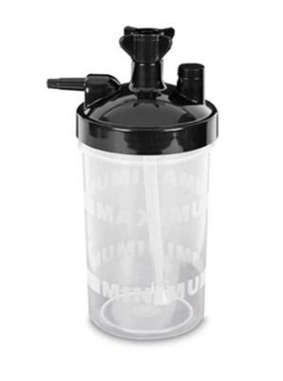

  - Weekly / Monthly
Weekly
• Clean the Device Exterior: Wipe down with a soft, damp cloth to remove dust.
• Clean the Filter Foam: Use water or soapy water to clean, then dry thoroughly. Replace the foam if it’s faulty.
Monthly
HEPA Filter Compartment: Wipe down with a soft, damp cloth to remove dust.

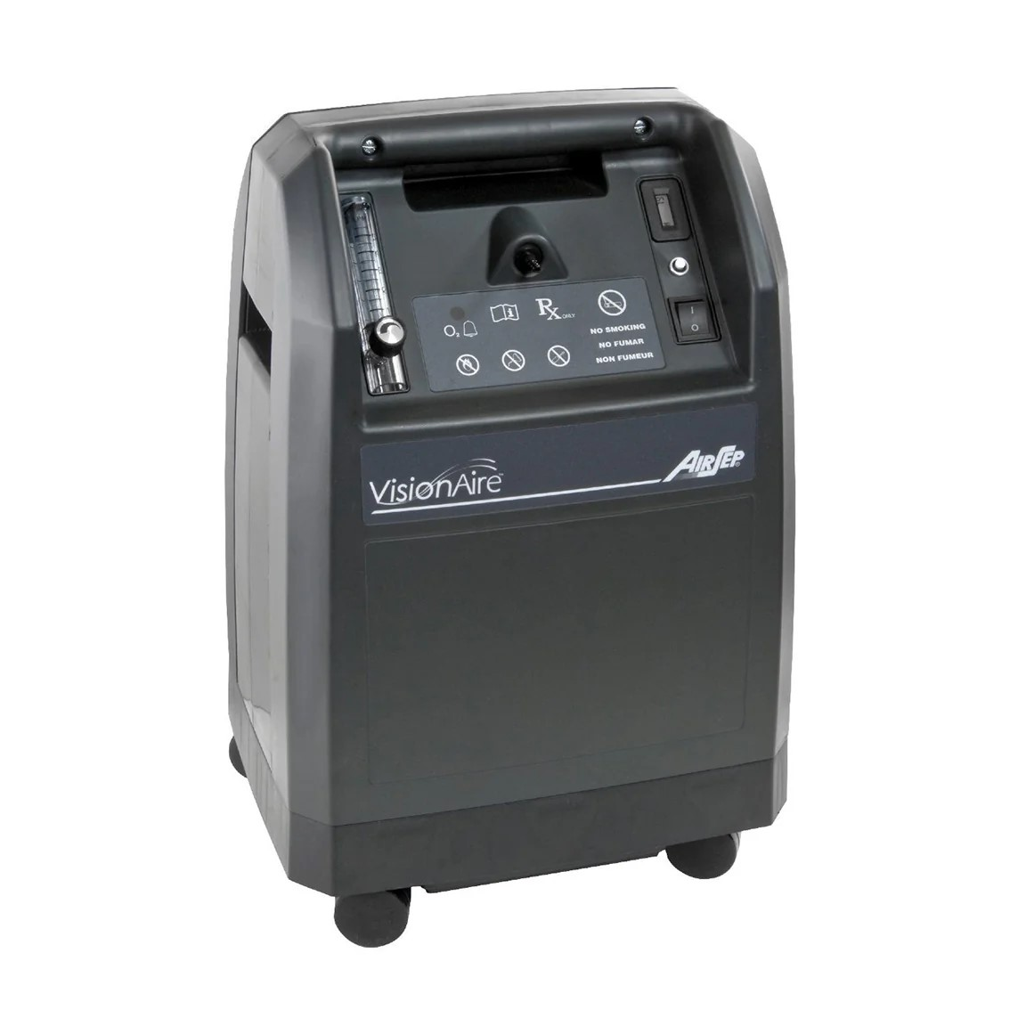
Device

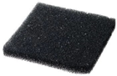

Oxygen Cannula / Masks
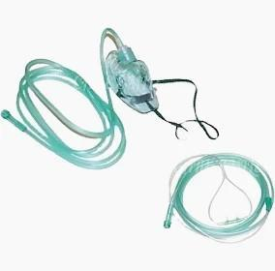
Monthly
Oxygen Cannula or Masks: Replace monthly, or sooner if they are faulty or very dirty

  - Yearly
Yearly
HEPA Filter: Replace yearly.
*Durability of this product is dependent on the product condition and environment*

HEPA Filter
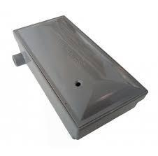
Note: The durability of filters and accessories depends on product condition and environmental factors.

